Expt No.7: Active Filters (Design Parameters)

Run1: Butterworth VCVS low-pass filter
${(ω}_{c})$= 2000 rad/s (or) fc = 318.3 Hz
Gain (K) = 10; $C_{1}$=$C_{2 }$= 1$μF$ ; $R_{A}$ = 1kΩ. and R_{B} = 9 kΩ
R₁= 138 Ω and R₂= 1.811 kΩ

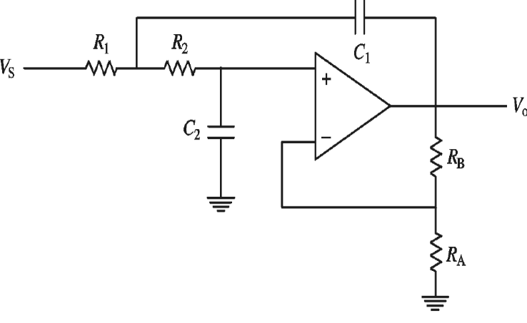
Run2: Butterworth VCVS high-pass filter:
${(ω}_{c})$= 2000 rad/s (or) fc = 318.3 Hz
Gain (K) = 10; $C_{1}$=$C_{2 }$= 1$μF$ ; $R_{A}$ = 1kΩ. and R_{B} = 9 kΩ
$R_{1}$= 1.25kΩ, $R_{2}$= 200Ω

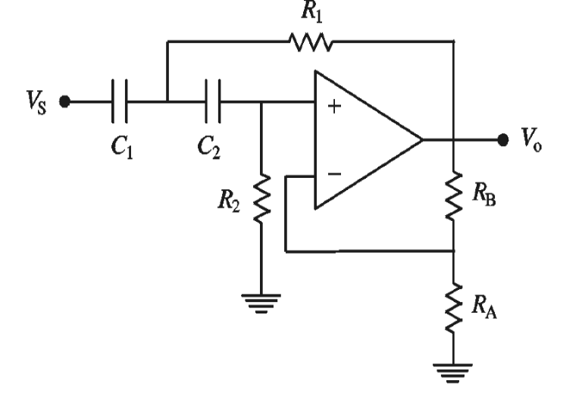
Run 3. Butterworth VCVS band-pass filter:
centre angular frequency,$ω_{c}$ = 2000 rad/s (or) fc = 318.3 Hz
Gain (at centrefrequency ($H_{o})$ = 2.
$R$ = 1 kΩ , $R_{A}$ =1 k$Ω.$, R_{B} = 1 kΩ
$C$= 0.5μF and $Q$ = 1
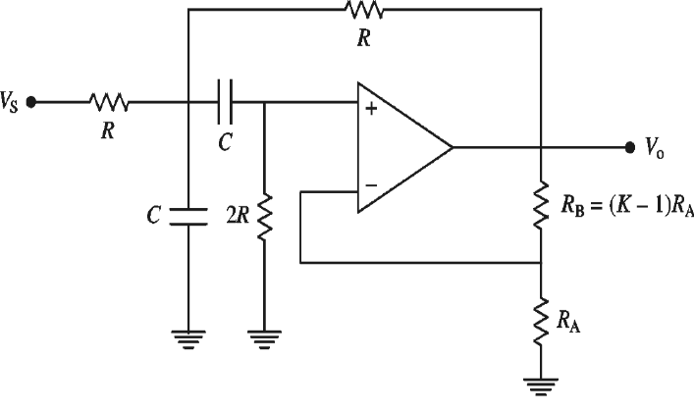

Run 4 : Butterworth VCVS band-reject filter (BRF):
center angular frequency,$ω_{c}$= 2000 rad/s and Q = 5.
Pass-band gain: $H_{o}$ = K = 1.9
R = 1 k$Ω$ , $R_{A}$ =1 k$Ω.$, R_{B} = 900 Ω ; C = 0.5μF,

